**Design and Implementation**

When we implemented our initial design we had a certain structure that we were going to follow. This was due to the market research that we had collected and testing done on our prototypes. As we went along with the first initial step which was to create a homepage and a login system, we did user testing and found out that we had to change aspects of our website. For example, our initial idea was to have the homepage as a login/registration form straight away. However after testing and feedback we realized that this structure does not display enough information to the user or anyone wanting to find out about our web app. That is why we decided to implement more information on the homepage and have a about page. This helped the user identify our brand. We had to make sure the users also knew how to navigate to the login page from the homepage and that is why we did the user testing and observed randomly selected users interacting with our website to make sure the user usability was still a high standard.

Another major design that we decided to amend was that in our design stage we were going to take inspiration from the App quick where you would have a extremely simple interface that suggest “Give help” and “Get help” but we decided to implement that idea into the login page. On our login page we have got 2 separate logins (One for tutors and parents) but it straight away prompts you to login instead of referring you to another page. We did this so that it becomes much easier for the user to navigate. According to Research done by Chao Liu (2010) the first 10 seconds after the user enters a website are extremely critical in whether a user will leave the website so that is why we decided to go for the much simpler design.

One of key components in our design concept was that we will use the Shibboleth authentication system to verify our student emails. The shibboleth is a Privacy Preserving Identity Management system which verifies students from any university to be valid. In our initial design it was a core part of our login system as it would do all the verification for us and therefore build a trust relationship between the parents and the web app. When we got to the implementation of the login systems, we couldn’t implement the open source Shibboleth system. The reason was because when we tried to implement Goldsmiths University shibboleth system, it wouldn’t let us since we needed full access to the Goldsmiths database and security system. We tried to organize a meeting with our database manager in order to implement it but it was not successful. So we had to adapt to it by making sure we had to validate the email form field by making sure it contained a university email, in that sense it would not allowed anything except university emails to be registered. And we also wanted to send a verification email to their university mailbox to make sure it is them. This is how we overcame the obstacle of not being able to use the Shibboleth system.

Since this was a major change in our initial design, we had to relate it back to the users to see if they found the adaption suitable. We decided to carry out user testing by observing and questioning. We had to make sure that our initial target market which were both tutors and parents were satisfied with the adaption and that it would still be a viable service even after this. Because one of the key issues with services that connect random people together is the fact of security. And there is a relationship trust between the service and the user which we as implementors are responsible for.

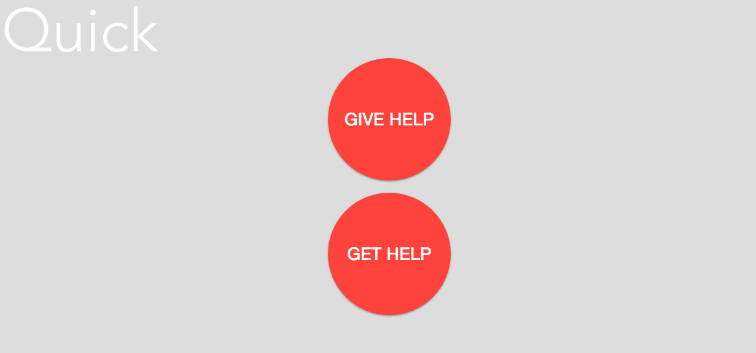

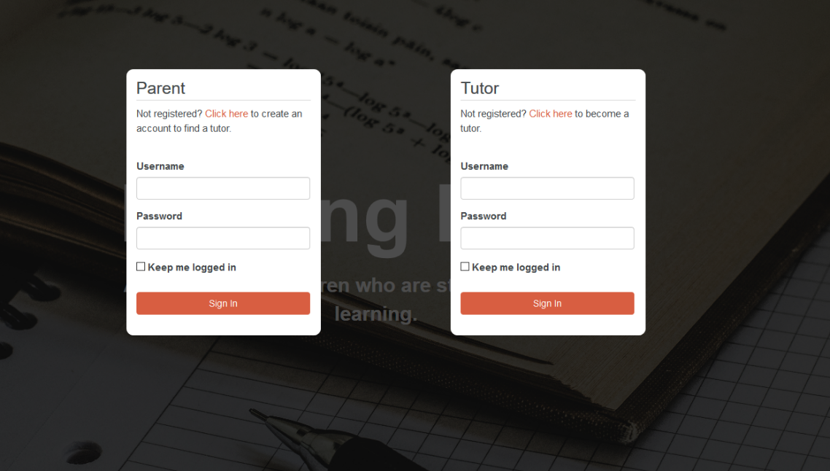

[Chao Liu, Ryen W. White, and Susan Dumais. 2010. Understanding web browsing behaviors through Weibull analysis of dwell time.](https://dl.acm.org/citation.cfm?doid=1835449.1835513) In Proceedings of the 33rd international ACM SIGIR conference on Research and development in information retrieval (SIGIR '10) [Accessed 13th march 2018]